Angular JS
Prepared by – Mansi Patel
Version 1.0
Tatvasoft
Table of Contents
1 Overview 5
1.1 What is AngularJS? 5
1.2 AngularJS Extends HTML 5
2 Features 6
2.1 General Features 6
2.2 Core Features 6
3 Advantages & Disadvantages 7
3.1 Advantages 7
3.2 Disadvantages 7
4 Concepts 8
5 AngularJS Components 9
6 How to Create AngularJS Application? 10
Step 1: Load framework 10
Step 2: Define AngularJS Application using ng-app directive 10
Step 3: Define a model name using ng-model directive 10
Step 4: Bind the value of above model defined using ng-bind directive. 10
7 AngularJS Directives 12
8 AngularJS Expression 14
8.1 AngularJS Expression vs. JavaScript Expression 14
8.2 How to use AngularJS Expression for Numbers? 16
8.3 How to use AngularJS Expression for Objects? 17
8.4 How to use AngularJS Expression for Arrays? 18
8.5 How to use AngularJS Expression for Arrays? 19
9 Controllers 20
9.1 How to Declare Controller? 20
9.2 How to Writing Controller? 20
9.3 How to use method in Controller? 22
10 Filters 23
10.1 Uppercase Filter 23
10.2 Lowercase Filter 23
10.3 Currency Filter 23
10.4 Filter Filter 23
10.5 Orderby Filter 24
11 AngularJS Tables 27
12 AngularJS HTML DOM 29
12.1 ng-disabled 29
12.2 ng-show 30
12.3 ng-hide 31
12.4 ng-click 32
13 AngularJS Forms 33
14 AngularJS Input Validation 35
14.1 Property of Validation & Example 35
15 AngularJS API 37
AngularJS Global API 37
15.1 angular.lowercase() 38
15.2 angular.upperrcase() 39
15.3 angular.isString() & angular.isNumber() 40
16 AngularJS Bootstrap 41
17 AngularJS Application 45

Revision History
Name | Date | Reason For Changes | Version
Mansi Patel | 06/09/2015 | Initial Draft | 1.0

Overview

What is AngularJS?
- AngularJS is an open source, JavaScript based web application development framework.

- Definition of AngularJS as put by its official documentation is as follows:

- AngularJS is a structural framework for dynamic web applications. It lets you use HTML as your template language and lets you extend HTML's syntax to express your application components clearly and succinctly. Its data binding and dependency injection eliminate much of the code you currently have to write. And it all happens within the browser, making it an ideal partner with any server technology. It was originally developed in 2009 by Misko Hevery and Adam Abrons. It is now maintained by Google.

- AngularJS is a JavaScript framework. It can be added to an HTML page with a <script> tag.

<script src="http://ajax.googleapis.com/ajax/libs/angularjs/1.3.14/angular.min.js"></script>

- AngularJS extends HTML attributes with Directives, and binds data to HTML with Expressions.

AngularJS Extends HTML
- AngularJS extends HTML with ng-directives.
- The ng-app directive defines an AngularJS application.
- The ng-model directive binds the value of HTML controls (input, select, and textarea) to application data.
- The ng-bind directive binds application data to the HTML view.

Features

General Features
- AngularJS is a efficient framework that can create Rich Internet Applications (RIA).
- AngularJS provides developers an options to write client side applications using JavaScript in a clean Model View Controller (MVC) way.
- Applications written in AngularJS are cross-browser compliant. AngularJS automatically handles JavaScript code suitable for each browser.
- AngularJS is open source, completely free, and used by thousands of developers around the world. It is licensed under the Apache license version 2.0.
- Overall, AngularJS is a framework to build large scale, high performance, and easy to-maintain web applications.

Core Features
- Data-binding: It is the automatic synchronization of data between model and view components.

- Scope: These are objects that refer to the model. They act as a glue between controller and view. 1. OVERVIEW Angular JS Tutorial 2

- Controller: These are JavaScript functions bound to a particular scope.

- Services: AngularJS comes with several built-in services such as $http to make a XMLHttpRequests. These are singleton objects which are instantiated only once in app.

- Filters: This select a subset of items from an array and returns a new array.

- Directives: Directives are markers on DOM elements such as elements, attributes, css, and more. These can be used to create custom HTML tags that serve as new, custom widgets. AngularJS has built-in directives such as ngBind, ngModel etc.

- Templates: These are the rendered view with information from the controller and model. These can be a single file (such as index.html) or multiple views in one page using partials.

- Routing: It is concept of switching views.

- Model View Whatever: MVW is a design pattern for dividing an application into different parts called Model, View, and Controller, each with distinct responsibilities. AngularJS does not implement MVC in the traditional sense, but rather something closer to MVVM (Model-View-ViewModel). The Angular JS team refers it humorously as Model View Whatever.

- Deep Linking: Deep linking allows you to encode the state of application in the URL so that it can be bookmarked. The application can then be restored from the URL to the same state.

- Dependency Injection: AngularJS has a built-in dependency injection subsystem that helps the developer to create, understand, and test the applications easily.

Advantages & Disadvantages

Advantages

- AngularJS provides capability to create Single Page Application in a very clean and maintainable way.

- AngularJS provides data binding capability to HTML. Thus, it gives user a rich and responsive experience.

- AngularJS code is unit testable.

- AngularJS uses dependency injection and make use of separation of concerns.

- AngularJS provides reusable components.

- With AngularJS, the developers can achieve more functionality with short code.

- In AngularJS, views are pure HTML pages, and controllers written in JavaScript do the business processing.

Disadvantages

- Not Secure : Being JavaScript only framework, application written in AngularJS are not safe. Server side authentication and authorization is must to keep an application secure.

- Not degradable: If the user of your application disables JavaScript, then nothing would be visible, except the basic page.

Concepts
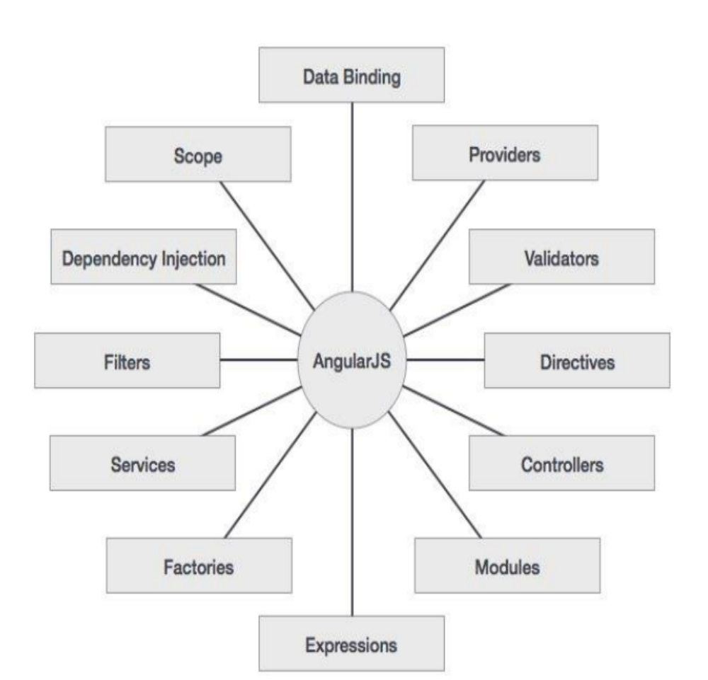

AngularJS Components
3 Components

ng-model
ng-app
ng-bind

- ng-app: This directive defines and links an AngularJS application to HTML.
- ng-model: This directive binds the values of AngularJS application data to HTML input controls.
- ng-bind: This directive binds the AngularJS Application data to HTML tags.
Note: You can use data-ng-, instead of ng-,if you want to
Make your page HTML valid.

How to Create AngularJS Application?

Step 1: Load framework
Being a pure JavaScript framework, It can be added using <Script> tag.
<script src="http://ajax.googleapis.com/ajax/libs/angularjs/1.3.14/angular.min.js "></script>

Step 2: Define AngularJS Application using ng-app directive
<div ng-app="">
…
</div>

Step 3: Define a model name using ng-model directive
<p>Enter your Name: <input type="text" ng-model="name"></p>

Step 4: Bind the value of above model defined using ng-bind directive.
<p>Hello <span ng-bind="name"></span>!</p>

- Example 1:-Simple Application using AngularJS

<html>
<title>AngularJS First Application</title>
<body>
<script src="http://ajax.googleapis.com/ajax/libs/angularjs/1.3.14/angular.min.js"></script>
<h1>Sample Application</h1>
<div ng-app="">
<p>Enter your Name: <input type="text" ng-model="name"></p>
<p>Hello <span ng-bind="name"></span>!</p>
</div>
</body>
</html>

- Output
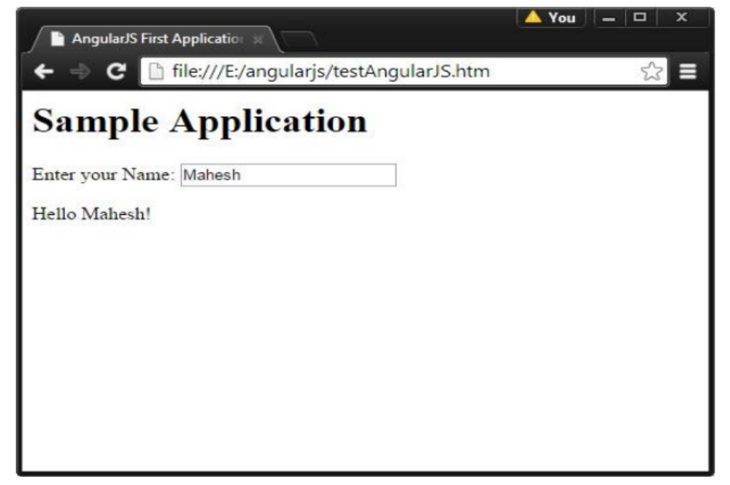

AngularJS Directives
- AngularJS directives are used to extend HTML. They are special attributes starting with ng-prefix.

- Let us discuss the following directives:

- ng-app - This directive starts an AngularJS Application. The ng-app directive starts an AngularJS Application. It defines the root element. It automatically initializes or bootstraps the application when the web page containing AngularJS Application is loaded. It is also used to load various AngularJS modules in AngularJS Application. In the following example, we define a default AngularJS application using ng-app attribute of a <div> element.
<div ng-app='' ''>
…...
</div>
- ng-init - This directive initializes application data. It is used to assign values to the variables. In the following example, we initialize an array of countries. We use JSON syntax to define the array of countries.

<div ng-app="" ng-init="countries=[{locale:'en-US',name:'United States'},
{locale:'en-GB',name:'United Kingdom'},
{locale:'en-FR',name:'France'}]">

- ng-model - This directive defines the model that is variable to be used in AngularJS.
<div ng-app='' ''>
<p>Enter your Name: <input type=''text'' ng-model=''name''></p>
</div>
- ng-repeat - This directive repeats HTML elements for each item in a collection. In the following example,
we iterate over the array of countries.
<div ng-app='' ''>
…...
<p>List of Countries with locale :</p>
<ol>
<li ng-repeat="country in countries">
{{‘Country: ' + country.name + ', Locale: ' + country.locale }}
</li>
</ol></div>

- Example 2
<html>
<title>AngularJS Directives</title>
<body>
<script src="http://ajax.googleapis.com/ajax/libs/angularjs/1.3.14/angular.min.js"></script>
<h1>Sample Application</h1>
<div ng-app="" ng-init="countries=[{locale:'en-US',name:'United States'},
{locale:'en-GB',name:'United Kingdom'},
{locale:'en-FR',name:'France'}]">
<p>Enter your Name: <input type="text" ng-model="name"></p>
<p>Hello <span ng-bind="name"></span>!</p>
<p>List of Countries with locale:</p>
<ol>
<li ng-repeat="country in countries">
{{ 'Country: ' + country.name + ', Locale: ' + country.locale }}
</li>
</ol>
</div>
</body>
</html>
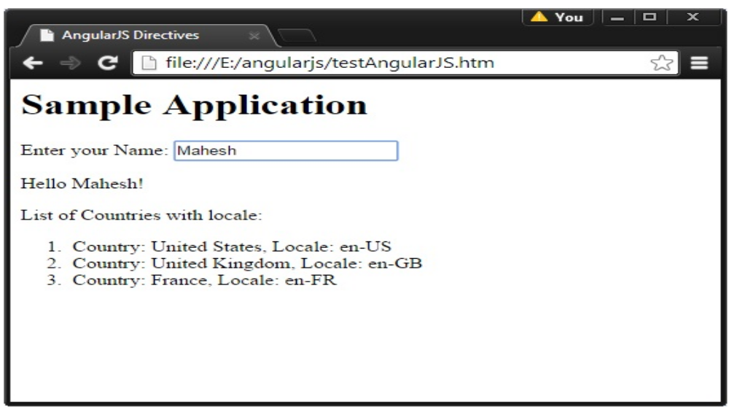
- Output

AngularJS Expression
- AngularJS binds data to HTML using Expressions.

- AngularJS expressions are written inside double braces: {{expression }}.

- An AngularJS expression binds data to HTML the same way as the ng-bind directive.

- AngularJS will "output" data exactly where the expression is written.

- AngularJS expressions are much like JavaScript expressions: They can contain literals, operators, and variables.

{{ 5 + 5 }} or {{ firstName + " " + lastName }}

AngularJS Expression vs. JavaScript Expression
Parameters | AngularJS Expression | JavaScript Expression
contain literals, operators, and variables | Expression are built using literals, operators, and variables | Expression are built using literals, operators, and variables
written inside HTML | Expression are written inside HTML | Expression are not written inside HTML
support conditionals, loops, or exceptions | Expression are not supporting conditionals, loops, or exceptions | Expression are supporting conditionals, loops, or exceptions
Support filters. | It supports filters. | It not support filters.

- Example 3
<! DOCTYPE html>
<html>
<script src= "http://ajax.googleapis.com/ajax/libs/angularjs/1.3.14/angular.min.js"></script>
<body>
<div ng-app='' ''>

<p>My first expression: {{ 5 + 5 }}</p>

</div>

</body>

</html>

- Output

My first expression: 10

How to use AngularJS Expression for Numbers?

- Example 4
<! DOCTYPE html>
<html>
<script src="http://ajax.googleapis.com/ajax/libs/angularjs/1.3.14/angular.min.js "></script>
<body>
<div ng-app="" ng-init="quantity=1; cost=5">
<p>Total in dollar: {{quantity * cost}}</p>
</div>
</body>
</html>

- Output

Total in dollar: 5

How to use AngularJS Expression for Objects?

- Example 5
<! DOCTYPE html>
<html>
<script src= "http://ajax.googleapis.com/ajax/libs/angularjs/1.3.14/angular.min.js"></script>
<body>
<div ng-app="" ng-init="person= {firstName:'John', lastName:'Doe'}">
<p>The name is {{person.lastName}} </p>
</div>
</body>
</html>

- Output: The name is Doe

How to use AngularJS Expression for Arrays?

- Example 6
<! DOCTYPE html>
<html>
<script src= "http://ajax.googleapis.com/ajax/libs/angularjs/1.3.14/angular.min.js"></script>
<body>
<div ng-app="" ng-init="points= [1, 15,19,2,40]">
<p>The third result is {{points [2] }}</p>
</div>
</body>
</html>

- Output: The third result is 19

How to use AngularJS Expression for Arrays?

- Example 7
<! DOCTYPE html>
<html>
<script src= "http://ajax.googleapis.com/ajax/libs/angularjs/1.3.14/angular.min.js"></script>
<body>
<div ng-app="" ng-init="person={firstName:'John',lastName:'Doe'}">
<p>The name is <span ng-bind="person.lastName"></span></p>
</div>
</body>
</html>

- Output: The name is Doe

Controllers
- AngularJS application mainly relies on controllers to control the flow of data in the application.
- A controller is defined using ng-controller directive.
- A controller is a JavaScript object that contains attributes/properties, and functions. Each controller accepts $scope as a parameter, which refers to the application/module that the controller needs to handle.
- We can also put controller in another JavaScript file.

How to Declare Controller?
<div ng-app="myApp" ng-controller="myCtrl">
…....
</div>

How to Writing Controller?
<script>
var app = angular.module('myApp', []);
app.controller ('myCtrl', function ($scope) {
$scope.firstName = "John";
$scope.lastName = "Doe";
});
</script>

- Example 8
<! DOCTYPE html>
<html>
<script src= "http://ajax.googleapis.com/ajax/libs/angularjs/1.3.14/angular.min.js">
</script>
<body>
<div ng-app="myApp" ng-controller="myCtrl">
First Name: <input type="text" ng-model="firstName"><br>
Last Name: <input type="text" ng-model="lastName"><br>
<br/>
Full Name: {{firstName + " " + lastName}}
</div>
<script>
var app = angular.module('myApp', []);
app.controller('myCtrl', function($scope) {
$scope.firstName = "John";
$scope.lastName = "Doe";
});
</script>
</body>
</html>

- Output
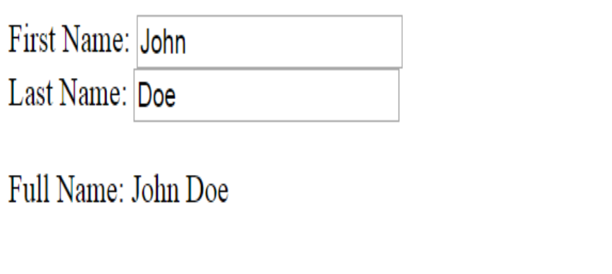

How to use method in Controller?
- Example 9
<!DOCTYPE html>
<html>
<script src= "http://ajax.googleapis.com/ajax/libs/angularjs/1.3.14/angular.min.js">
</script>
<body>
<div ng-app="myApp" ng-controller="personCtrl">
First Name: <input type="text" ng-model="firstName"><br>
Last Name: <input type="text" ng-model="lastName"><br>
<br>
Full Name: {{fullName ()}}
</div>
<script>
var app = angular.module('myApp', []);
app.controller ('personCtrl', function($scope) {
$scope.firstName = "John";
$scope.lastName = "Doe";
$scope.fullName = function () {
return $scope.firstName + " " + $scope.lastName;
}
});
</script>
</body>
</html>

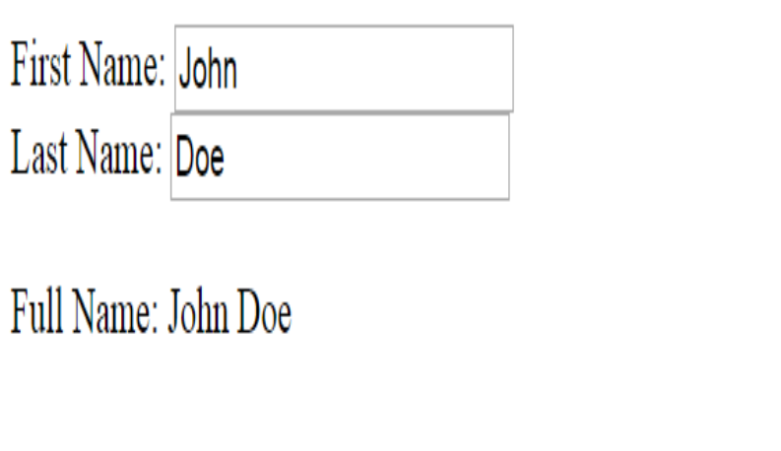
- Output

Filters
- Filters are used to modify the data.
- They can be clubbed in expression or directives using pipe (|) character.

Name | Description
Uppercase | Format a string to upper case.
Lowercase | Format a string to lower case.
Orderby | Orders an array by an expression.
Filter | Select a subset of items from an array.
currency | Format a number to a currency format.

Uppercase Filter
This adds uppercase filter to an expression using pipe character. Here, we add uppercase filter to print student name in capital letters.
Enter first name :<input type="text" ng-model="student.firstName">
Enter last name: <input type="text" ng-model="student.lastName">
Name in Upper Case: {{student.fullName () | uppercase}}

Lowercase Filter
This adds lowercase filter to an expression using pipe character. Here, we add lowercase filter to print student name in small letters.
Enter first name :<input type="text" ng-model="student.firstName">
Enter last name: <input type="text" ng-model="student.lastName">
Name in Upper Case: {{student.fullName () | lowercase}}

Currency Filter
This adds currency filter to an expression that returns a number. Here, we add currency filter to print fees using currency format.

Enter fees: <input type="text" ng-model="student.fees">
fees: {{student.fees | currency}}

Filter Filter
To display only required subjects, we use subjectName as filter.

Enter subject: <input type="text" ng-model="subjectName">
Subject:
<ul>
<li ng-repeat="subject in student.subjects | filter: subjectName">
{{ subject.name + ', marks:' + subject.marks}}
</li>

Orderby Filter
To order subjects by marks, we use orderBy marks.
Subject:
<ul>
<li ng-repeat="subject in student.subjects | orderBy:'marks'">
{{ subject.name + ', marks:' + subject.marks}}
</li>
</ul>

- Example 10
<!DOCTYPE html>
<html>
<head>
<title>Angular JS Filters</title>
<script src="http://ajax.googleapis.com/ajax/libs/angularjs/1.3.14/angular.min.js"></script>
</head>
<body>
<h2>AngularJS Sample Application</h2>
<div data-ng-app="mainApp" data-ng-controller="studentController">
<table border="0">
<tr>
<td>Enter first name:</td>
<td>
<input type="text" data-ng-model="student.firstName"></td>
</tr>
<tr>
<td>Enter last name: </td>
<td>
<input type="text" data-ng-model="student.lastName"></td>
</tr>
<tr>
<td>Enter fees: </td>
<td>
<input type="text" data-ng-model="student.fees"></td>
</tr>
<tr>
<td>Enter subject: </td>
<td>
<input type="text" data-ng-model="subjectName"></td>
</tr>
</table>
<br />
<table border="0">
<tr>
<td>Name in Upper Case: </td>
<td>{{student.fullName() | uppercase}}</td>
</tr>
<tr>
<td>Name in Lower Case: </td>
<td>{{student.fullName() | lowercase}}</td>
</tr>
<tr>
<td>fees: </td>
<td>{{student.fees | currency}}</td>
</tr>
<tr>
<td>Subject:</td>
<td>
<ul>
<li data-ng-repeat="subject in student.subjects | filter: subjectName |orderBy:'marks'">{{ subject.name + ', marks:' + subject.marks }}
</li>
</ul>
</td>
</tr>
</table>
</div>
<script>
var mainApp = angular.module("mainApp", []);

mainApp.controller('studentController', function ($scope) {
$scope.student = {
firstName: "Mahesh",
lastName: "Parashar",
fees: 500,
subjects: [
{ name: 'Physics', marks: 70 },
{ name: 'Chemistry', marks: 80 },
{ name: 'Math', marks: 65 }
],
fullName: function () {
var studentObject;
studentObject = $scope.student;
return studentObject.firstName + " " + studentObject.lastName;
}
};
});
</script>
</body>
</html>

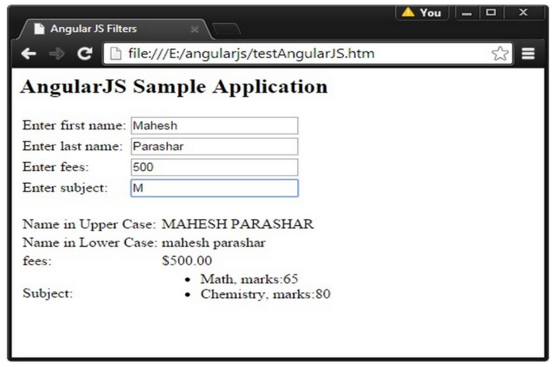
- Output

AngularJS Tables
- Using AngularJS Data, It is possible to display data more conveniently and easily in Tables.
- Table data is generally repeatable. The ng-repeat directive can be used to draw table easily.

- Example 11
<!DOCTYPE html>
<html>
<style>
table, th , td {
border: 1px solid grey;
border-collapse: collapse;
padding: 5px;
}
table tr:nth-child(odd) {
background-color: #f1f1f1;
}
table tr:nth-child(even) {
background-color: #ffffff;
}
</style>
<script src= "http://ajax.googleapis.com/ajax/libs/angularjs/1.3.14/angular.min.js"></script>
<body>

<div ng-app="myApp" ng-controller="customersCtrl">

<table>
<tr ng-repeat="x in names">
<td>{{ x.Name }}</td>
<td>{{ x.Country }}</td>
</tr>
</table>

</div>

<script>
var app = angular.module('myApp', []);
app.controller('customersCtrl', function ($scope, $http) {
$http.get("http://www.w3schools.com/angular/customers.php")
.success(function (response) { $scope.names = response.records; });
});
</script>

</body>
</html>

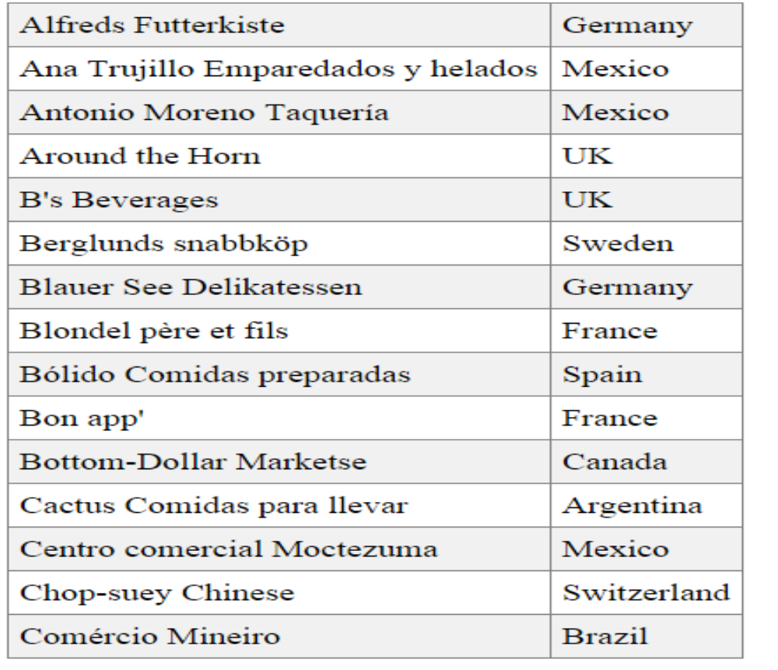
- Output

AngularJS HTML DOM
- AngularJS has directives for binding application data to the attributes of HTML DOM elements.

Name | Description
ng-disabled | Disables a given control.
ng-show | Shows a given control.
ng-hide | Hides a given control.
ng-click | Represents a AngularJS click event.

ng-disabled
- Example 12
<!DOCTYPE html>
<html>
<script src="http://ajax.googleapis.com/ajax/libs/angularjs/1.3.14/angular.min.js">
</script>
<body>
<div ng-app="" ng-init="mySwitch=true">
<p><button ng-disabled="mySwitch">Click Me!</button></p>
<p><input type="checkbox" ng-model="mySwitch"/>Button</p>
<p>
{{ mySwitch }}
</p>
</div>
</body></html>

- Output
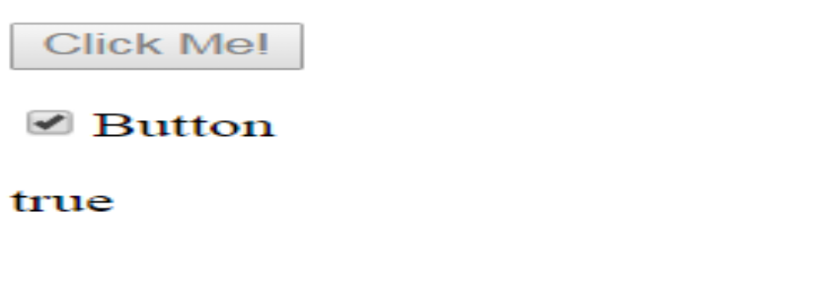

ng-show
- Example 13

<!DOCTYPE html>
<html>
<script src= "http://ajax.googleapis.com/ajax/libs/angularjs/1.3.14/angular.min.js"></script>
<body>
<div ng-app="">
<p ng-show="true">I am visible.</p>
<p ng-show="false">I am not visible.</p>
</div>
</body>
</html>

- Output



ng-hide
- Example 14

<!DOCTYPE html>
<html>
<script src= "http://ajax.googleapis.com/ajax/libs/angularjs/1.3.14/angular.min.js"></script>
<body>
<div ng-app="">
<p ng-hide="true">I am not visible.</p>
<p ng-hide="false">I am visible.</p>
</div>
</body>
</html>

- Output



ng-click
- Example 15
<!DOCTYPE html>
<html>
<script src= "http://ajax.googleapis.com/ajax/libs/angularjs/1.3.14/angular.min.js"></script>
<body>
<div ng-app="myApp" ng-controller="myCtrl">
<button ng-click="count = count + 1">Click Me!</button>
<p>{{ count }}</p>
</div>
<script>
var app = angular.module('myApp', []);
app.controller ('myCtrl', function($scope) {
$scope.count = 0;
});
</script>
</body>
</html>

- Output



AngularJS Forms
- An AngularJS form is a collection of input controls.
- AngularJS enriches form filling and validation.
- We can use ng-click event to handle the click button and use $dirty and $invalid flags to do the validation in a seamless way. Use novalidate with a form declaration to disable any browser-specific validation. The form controls make heavy use of AngularJS events.
- HTML Controls
HTML input elements are called HTML controls:
- input elements
- select elements
- button elements
- textarea elements
HTML forms group HTML controls together.
- Form Events
AngularJS provides multiple events associated with the HTML controls. For example, ng-click directive is generally associated with a button.
- ng-click
- ng-dbl-click
- ng-mousedown
- ng-mouseup
- ng-mouseenter
- ng-mouseleave
- ng-mousemove
- ng-mouseover
- ng-keydown
- ng-keyup
- ng-keypress
- ng-change

- Example 16
<!DOCTYPE html>
<html lang="en">
<script src= "http://ajax.googleapis.com/ajax/libs/angularjs/1.3.14/angular.min.js"></script>
<body>
<div ng-app="myApp" ng-controller="formCtrl">
<form novalidate>
First Name:<br>
<input type="text" ng-model="user.firstName"><br>
Last Name:<br>
<input type="text" ng-model="user.lastName"> <br><br>
<button ng-click="reset()">RESET</button>
</form>
<p>form = {{user }}</p>
<p>master = {{master}}</p>
</div>
<script>
var app = angular.module('myApp', []);
app.controller('formCtrl', function($scope) {
$scope.master = {firstName:"John", lastName:"Doe"};
$scope.reset = function() {
$scope.user = angular.copy($scope.master);
};
$scope.reset();
});
</script>
</body>
</html>
- Output
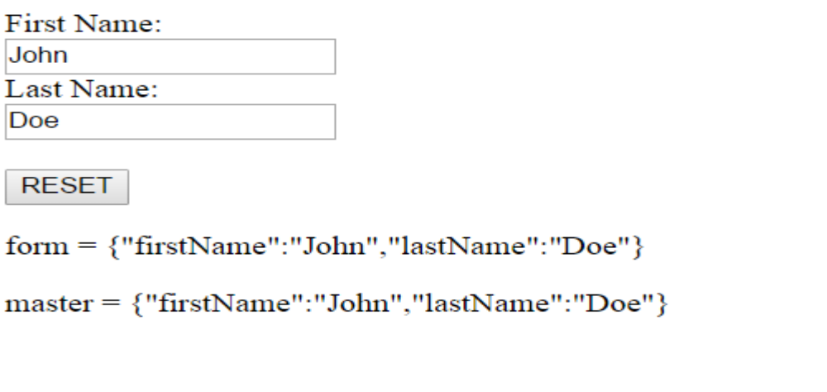

AngularJS Input Validation
- AngularJS forms and controls can validate input data.
- AngularJS forms and controls can provide validation services, and notify users of invalid input.
Note: Client-side validation cannot alone secure user input.
Server side validation is also necessary.

Property of Validation & Example

Property | Description
$dirty | The user has interacted with the field.
$valid | The field content is valid.
$invalid | The field content is invalid.
$pristine | User has not interacted with the field yet.

- Example 17
<!DOCTYPE html>
<html>
<script
src= "http://ajax.googleapis.com/ajax/libs/angularjs/1.3.14/angular.min.js">
</script>
<body>
<h2>Validation Example</h2>
<form ng-app="myApp" ng-controller="validateCtrl"
name="myForm" novalidate>
<p>Username:<br>
<input t type="text" name="user" ng-model="user" required>
<span style="color:red" ng-show="myForm.user.$dirty && myForm.user. $invalid">
<span ng-show="myForm.user.$error.required">Username is required.</span>
</span>
</p>
<p>Email:<br>
<input type="email" name="email" ng-model="email" required>
<span style="color:red" ng-show="myForm.email.$dirty && myForm.email.$invalid">
<span ng-show="myForm.email.$error.required">Email is required.</span>
<span ng-show="myForm.email.$error.email">Invalid email address.</span>
</span>
</p>
<p>
<input type="submit"
ng-disabled="myForm.user.$dirty && myForm.user.$invalid ||
myForm.email.$dirty && myForm.email.$invalid">
</p>
</form>
<script>
var app = angular.module('myApp', []);
app.controller('validateCtrl', function($scope) {
$scope.user = 'John Doe';
$scope.email = 'john.doe@gmail.com';
});
</script>
</body>
</html>

- Output

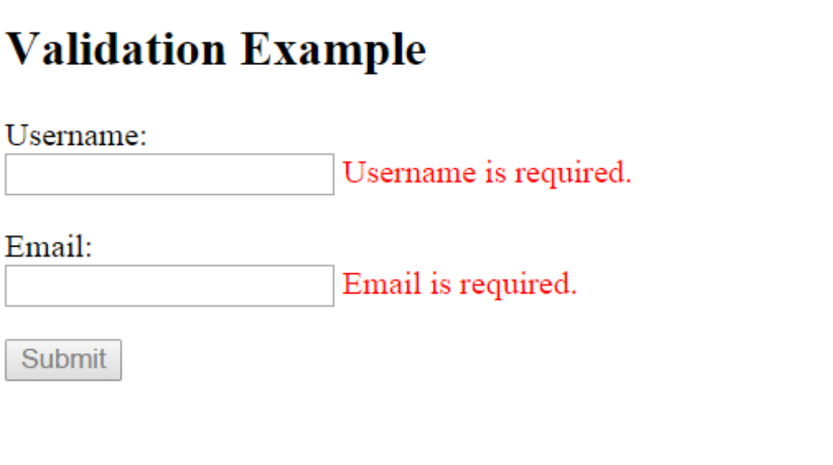

AngularJS API
- API stands for Application Programming Interface.

AngularJS Global API
- The AngularJS Global API is a set of global JavaScript functions for performing common tasks like:
  - Comparing objects
  - Iterating objects
  - Converting data

- The Global API functions are accessed using the angular object.
- Below is a list of some common Angular API functions:

API Function | Description
angular.lowercase() | Converts a string to lowercase
angular.uppercase() | Converts a string to uppercase
angular.isString() | Returns true if the reference is a string
angular.isNumber() | Returns true if the reference is a number

angular.lowercase()
- Example 18
<!DOCTYPE html>
<html>
<script src="http://ajax.googleapis.com/ajax/libs/angularjs/1.3.14/angular.min.js">
</script>
<body>
<div ng-app="myApp" ng-controller="myCtrl">
<p>{{ x1 }}</p>
<p>{{ x2 }}</p>
</div>
<script>
var app = angular.module('myApp', []);
app.controller('myCtrl', function($scope) {
$scope.x1 = "JOHN";
$scope.x2 = angular.lowercase($scope.x1);
});
</script>
</body>
</html>

- Output
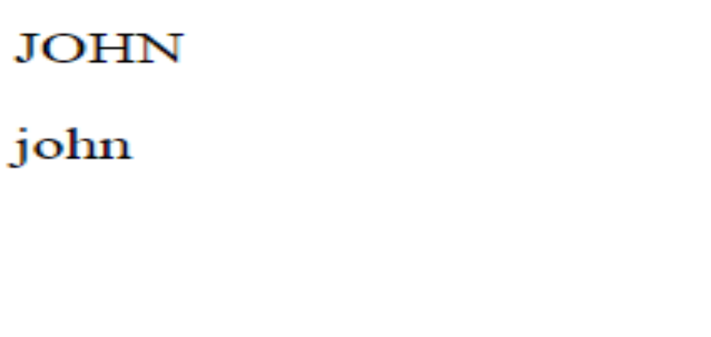

angular.upperrcase()
- Example 19
<! DOCTYPE html>
<html>
<script src="http://ajax.googleapis.com/ajax/libs/angularjs/1.3.14/angular.min.js">
</script>
<body>
<div ng-app="myApp" ng-controller="myCtrl">
<p>{{ x1 }}</p>
<p>{{ x2 }}</p>
</div>
<script>
var app = angular.module('myApp', []);
app.controller('myCtrl', function($scope) {
$scope.x1 = "JOHN";
$scope.x2 = angular.lowercase($scope.x1);
});
</script>
</body>
</html>

- Output
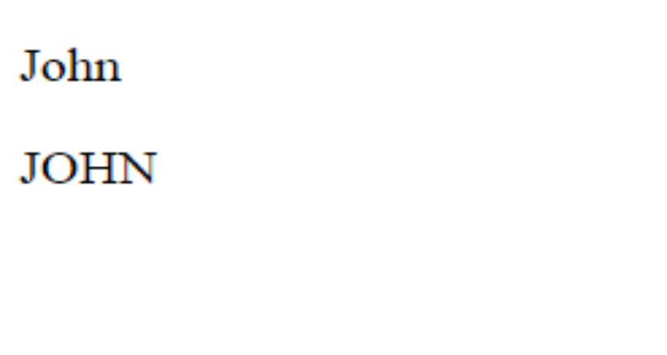

angular.isString() & angular.isNumber()
- Example 20
<!DOCTYPE html>
<html>
<script src="http://ajax.googleapis.com/ajax/libs/angularjs/1.3.14/angular.min.js">
</script>
<body>
<div data-ng-app="myApp" data-ng-controller="myCtrl">
<p><b>X1:</b>{{ x1 }}</p>
<p><b>X1 is String:</b>{{ x2 }}</p>
<p><b>X1 is Number:</b>{{ x3 }}</p>
</div>

<script>
var app = angular.module('myApp', []);
app.controller('myCtrl', function ($scope) {
$scope.x1 = "JOHN";
$scope.x2 = angular.isString($scope.x1);
$scope.x3 = angular.isNumber($scope.x1);
});
</script>
</body>
</html>

- Output
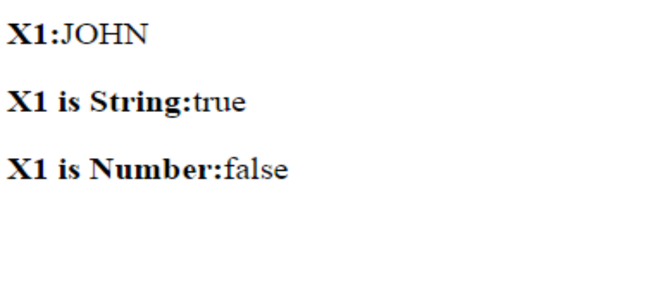

AngularJS Bootstrap
- Bootstrap is a popular style sheet. This chapter demonstrates how to use it with AngularJS.
- To include Bootstrap in your AngularJS application, add the following line to the head of your document

<link rel="stylesheet" href="http://maxcdn.bootstrapcdn.com/bootstrap/3.2.0/css/bootstrap.min.css">

- Example 21
HTML Code:

<!DOCTYPE html>
<html>
<link rel="stylesheet" href ="http://maxcdn.bootstrapcdn.com/bootstrap/3.2.0/css/bootstrap.
min.css">
<script src= "http://ajax.googleapis.com/ajax/libs/angularjs/1.3.14/angular.min.js"></script>
<body ng-app="myApp" ng-controller="userCtrl">
<div class="container">
<h3>Users</h3>
<table class="table table-striped">
<thead>
<tr>
<th>Edit</th>
<th>First Name</th>
<th>Last Name</th>
</tr>
</thead>
<tbody>
<tr ng-repeat="user in users">
<td>
<button class="btn" ng-click="editUser(user.id)">
<span class="glyphicon glyphicon-pencil"></span>Edit
</button>
</td>
<td>{{ user.fName }}</td>
<td>{{ user.lName }}</td>
</tr>
</tbody>
</table>
<hr>
<button class="btn btn-success" ng-click="editUser('new')">
<span class="glyphicon glyphicon-user"></span> Create New User
</button>
<hr>
<h3 ng-show="edit">Create New User:</h3>
<h3 ng-hide="edit">Edit User:</h3>
<form class="form-horizontal">
<div class="form-group">
<label class="col-sm-2 control-label">First Name:</label>
<div class="col-sm-10">
<input type="text" ng-model="fName" ng-disabled="!edit" placeholder="FirstName">
</div>
</div>
<div class="form-group">
<label class="col-sm-2 control-label">Last Name:</label>
<div class="col-sm-10">
<input type="text" ng-model="lName" ng-disabled="!edit" placeholder="Last Name">
</div>
</div>
<div class="form-group">
<label class="col-sm-2 control-label">Password:</label>
<div class="col-sm-10">
<input type="password" ng-model="passw1" placeholder="Password">
</div>
</div>
<div class="form-group">
<label class="col-sm-2 control-label">Repeat:</label>
<div class="col-sm-10">
<input type="password" ng-model="passw2" placeholder="Repeat Password">
</div>
</div>
</form>
<hr>
<button class="btn btn-success" ng-disabled="error || incomplete">
<span class="glyphicon glyphicon-save"></span> Save Changes
</button>
</div>
<script src= "myUsers.js"></script>
</body>
</html>

JavaScript Code:

angular.module('myApp', []).controller('userCtrl', function($scope) {
$scope.fName = '';
$scope.lName = '';
$scope.passw1 = '';
$scope.passw2 = '';
$scope.users = [
{id:1, fName:'Hege', lName:"Pege" },
{id:2, fName:'Kim', lName:"Pim" },
{id:3, fName:'Sal', lName:"Smith" },
{id:4, fName:'Jack', lName:"Jones" },
{id:5, fName:'John', lName:"Doe" },
{id:6, fName:'Peter', lName:"Pan" }
];
$scope.edit = true;
$scope.error = false;
$scope.incomplete = false;

$scope.editUser = function(id) {
if (id == 'new') {
$scope.edit = true;
$scope.incomplete = true;
$scope.fName = '';
$scope.lName = '';
} else {
$scope.edit = false;
$scope.fName = $scope.users[id-1].fName;
$scope.lName = $scope.users[id-1].lName;
}
};
$scope.$watch('passw1',function() {$scope.test();});
$scope.$watch('passw2',function() {$scope.test();});
$scope.$watch('fName', function() {$scope.test();});
$scope.$watch('lName', function() {$scope.test();});
$scope.test = function() {
if ($scope.passw1 !== $scope.passw2) {
$scope.error = true;
} else {
$scope.error = false;
}
$scope.incomplete = false;
if ($scope.edit && (!$scope.fName.length ||
!$scope.lName.length ||
!$scope.passw1.length || !$scope.passw2.length)) {
$scope.incomplete = true;
}
};
});

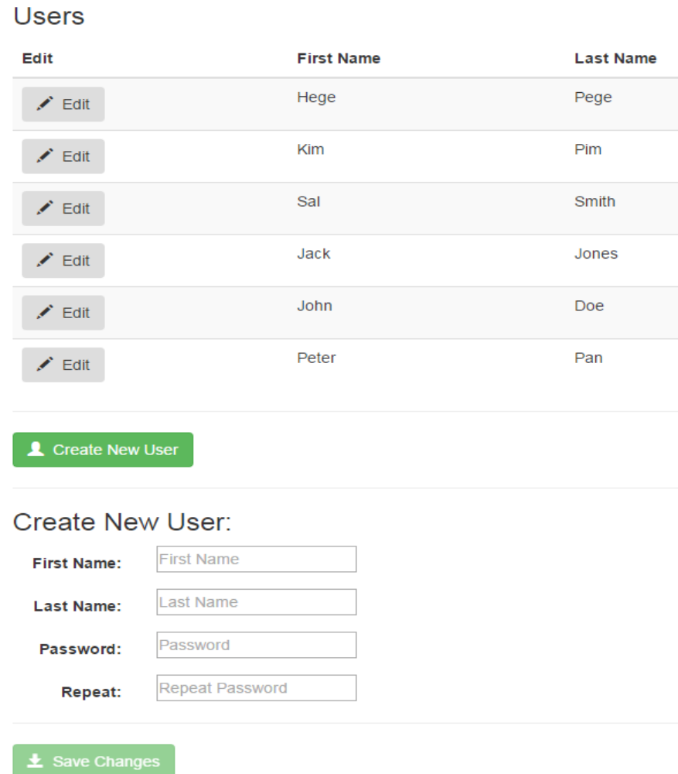
- Output

AngularJS Application
- It is time to create a real AngularJS Single Page Application (SPA).

- Example 22

<!DOCTYPE html>
<html>
<script src=
"http://ajax.googleapis.com/ajax/libs/angularjs/1.3.14/angular.min.js"> </script>
<body ng-app="myNoteApp" ng-controller="myNoteCtrl">
<h2>My Note</h2>
<textarea ng-model="message" cols="40" rows="10"></textarea>
<p>
<button ng-click="save()">Save</button>
<butt on ng-click="clear()">Clear</button>
</p>
<p>Number of characters left: <span ng-bind="left()"></span></p>
<script src="myNoteApp.js"></script>
<script src="myNoteCtrl.js"></script>
</body>
</html>

- myNotApp.js:

var app = angular.module("myNoteApp", []);

- myNoteCtrl.js:

app.controller ("myNoteCtrl", function($scope) {
$scope.message = "";
$scope.left = function() {return 100 - $scope.message.length;};
$scope.clear = function () {$scope.message = "";};
$scope.save = function() {alert("Note Saved");};
});

- Output

